Quick Start Coding for DeGAUSS Compatible with Windows/PC Users:
Everyone, including Mac users, please read the original directions for how to geocode for PAC³ here: https://degauss.org/pac3.html
- Set up your CSV file
Open Excel and create a worksheet with two headers id and address
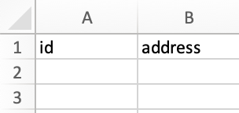
Enter the HOSPITALIZATION ID under id and the patient’s address under address
After entering the necessary data for your DeGAUSS run save the file as a .csv
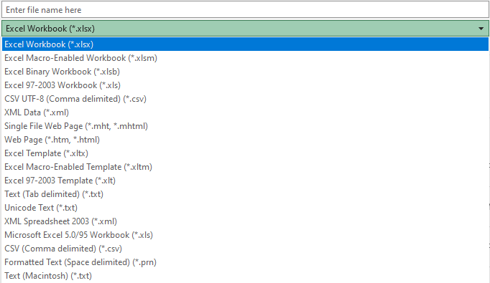
2. First run your csv file through the geocoder image
Enter the address of YOUR C drive (mine personally is C:\Users\brhill but yours will be different). In this example, my csv file is just called “test.csv”.
Note: the files must not have spaces and must include “.csv” when running the image.
Docker must be open when running any code. The name of the file in red must be changed to the name you assigned your file for each code.

C:\Users\brhill>docker run --rm -v "%cd%":/tmp ghcr.io/degauss-org/geocoder:3.0.2 test.csv
The output of this will be a csv file with a different name. In my case, it was test_geocoded_v3.0.2.csv, so this is what we will plug into the code in the command prompt for other images like drivetime and dep_index
Example below:
- Code for running the csv file to get information from dep_index and drivetime.
Deprivation Index code
C:\Users\brhill>docker run --rm -v "%cd%":/tmp ghcr.io/degauss-org/dep_index:0.1 test_geocoded_v3.0.2.csv
Note for drivetime, you need to put your institution name after the csv file name so the drivetime image knows from which geographic point to subtract distance from a patient’s home. You can find the abbreviation for each center in the drivetime in DeGAUSS here and copied below. In my example, the abbreviation for Children’s Medical Center Dallas is dallas:
Drivetime
C:\Users\brhill> docker run --rm -v "%cd%":/tmp ghcr.io/degauss-org/drivetime:1.0 test_geocoded_v3.0.2_dep_index_v0.1.csv dallas

Example below:

Please refer to https://pac3quality.org/health-equity-module/ for additional information
Drivetime Codes

Name | abbreviation
Children’s Hospital of Philadelphia | chop
Riley Hospital for Children, Indiana University | riley
Seattle Children’s Hospital | seattle
Children’s Mercy Hospital | mercy
Emory University | emory
Johns Hopkins University | jhu
Cleveland Clinc | cc
Levine Children’s | levine
St. Louis Children’s Hospital | stl
Oregon Health and Science University | ohsu
University of Michigan Health System | umich
Children’s Hospital of Alabama | al
Cincinnati Children’s Hospital Medical Center - Main Campus | cchmc
Cincinnati Children’s Hospital Medical Center - Liberty Campus | liberty
Nationwide Children’s Hospital | nat
University of California, Los Angeles | ucla
Boston Children’s Hospital | bch
Medical College of Wisconsin | mcw
St. Jude’s Children’s Hospital | stj
Martha Eliot Health Center | mehc
Northwestern / Ann & Lurie Children’s Northwestern | nwu
Lurie Children’s Outpatient Center in Northbrook | lcclp
Lurie Children’s Outpatient Center in Lincoln Park | lcclp
Lurie Children’s Outpatient Center in Uptown | lccu
Dr. Lio’s and Dr. Aggarwal’s clinics | lac
Recruited from Eczema Expo 2018 | expo
University of California San Francisco Benioff Children’s Hospital | ucsf
Nicklaus Children’s Hospital | nicklaus
Medical University of South Carolina Children’s Hospital | musc
Children’s National Medical Center | cnmc
Children’s Hospital of Pittsburgh of UPMC | upmc
Methodist LeBonheur Children’s Hospital | methodist
Texas Children’s Hospital | texas
Arkansas Children’s Hospital | arkansas
Primary Children’s Medical Center | primary
Children’s Healthcare of Atlanta | atlanta
Children’s Medical Center of Dallas | dallas
Lucile Packard Children’s Hospital Stanford | packard
Toronto Hospital for Sick Children | toronto
Cook Children’s Medical Center | cook
Children’s Hospital & Medical Center - Omaha | omaha
Children’s Hospital Colorado | colorado
Arnold Palmer Hospital for Children | palmer
Children’s Hospital & Clinics of Minnesota | minn
University of Virginia Hospital | uva
Joe Dimaggio Children’s Hospital | dimaggio
Cohen Children’s Medical Center of New York at Northwell Health | cohen
Dell Children’s Medical Center of Central Texas | dell
A.I. duPont Hospital for Children | dupont
Rainbow Babies and Children’s Hospital | rainbow
UNC Hospitals Children’s Specialty Clinic | unc
Barbara Bush Children’s Hospital at Maine Medical | maine
Children’s Hospital of New Orleans | chnola
Rady Children’s Hospital | rady
Children’s Hospital Los Angeles | chla
Monroe Carell Jr. Children’s Hospital at Vanderbilt | vandy

